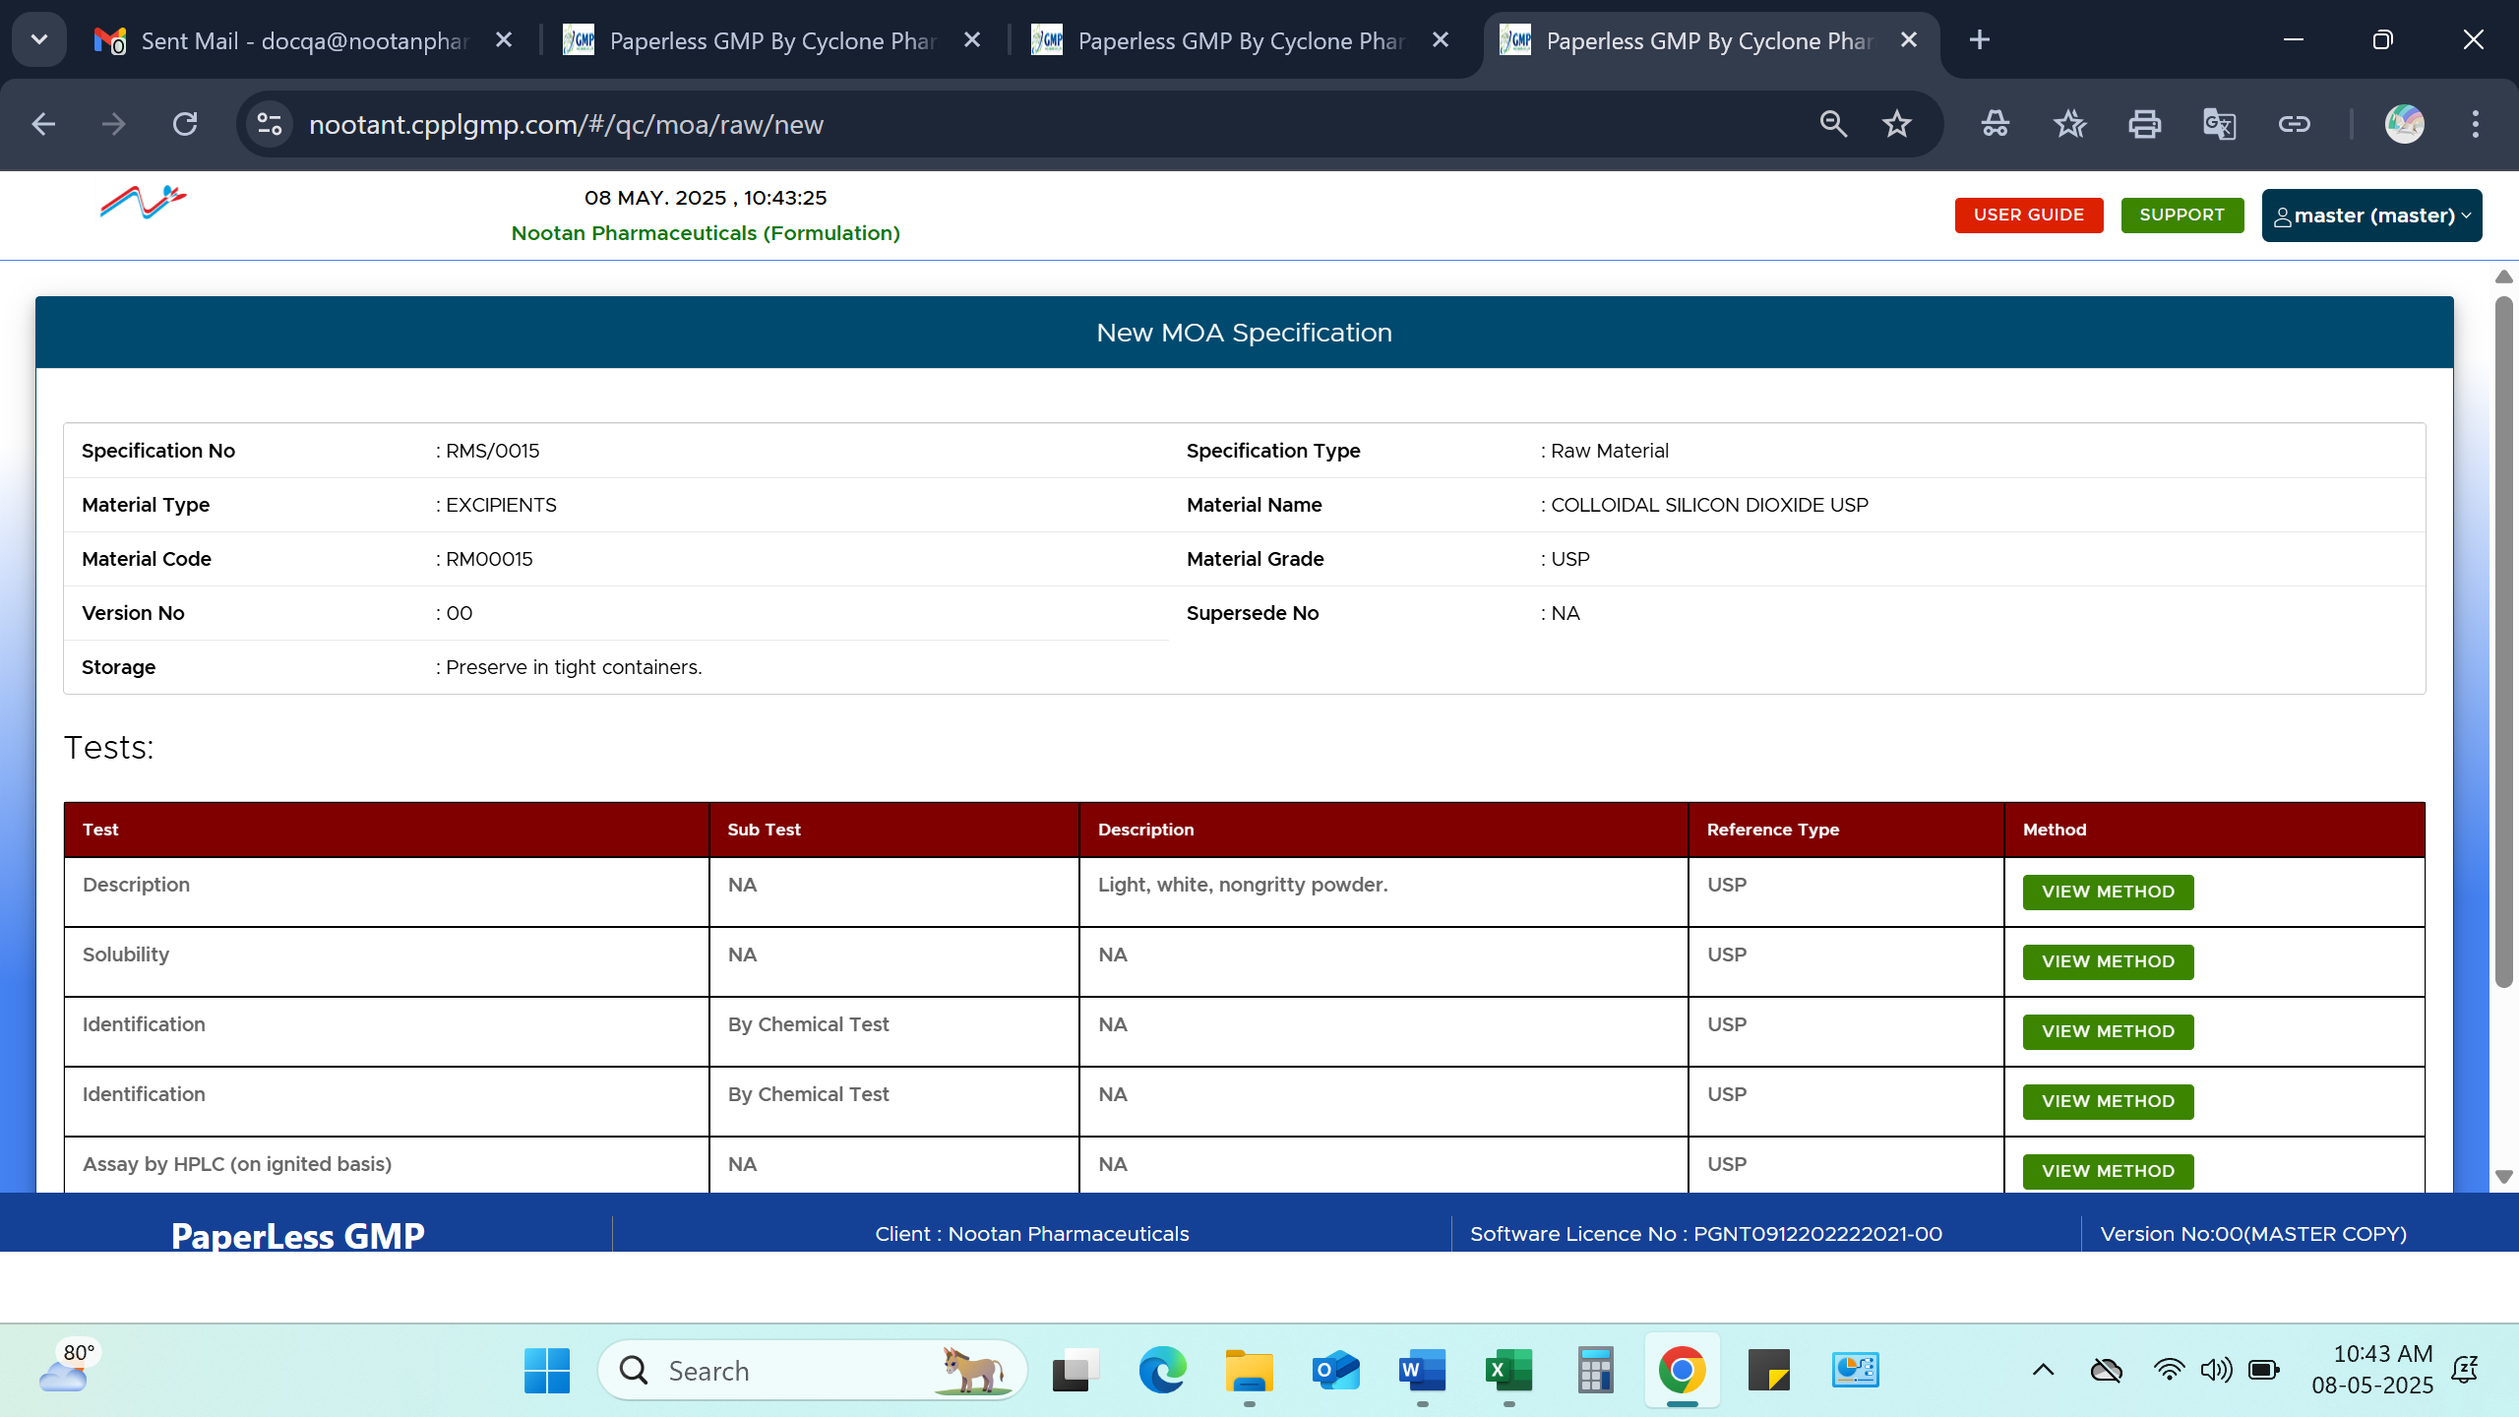

STP No. should be different.

Header of MOA should be contain details related to MOA not specification and its respective spec no only.